Unico Programming Assignment Document

REST Web Service

Class Diagram:
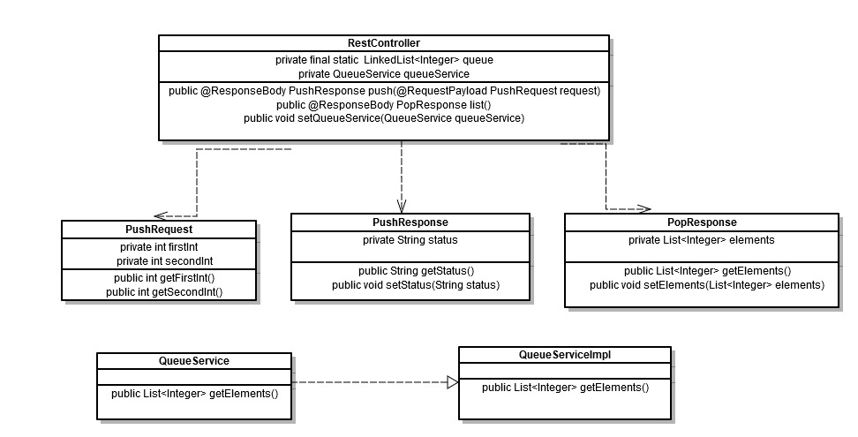

Implementation:
JAX_RS Spring Implementation:
Used Spring framework Web service implementations. Spring Web Services is following the strategy of contract-first web services.

Implementation Steps Followed:
- In order to add two parameters to a JMS queue and returns the status of the request to the caller as a String. Created a XSD QueueOperations.XSD which include PushRequest and PushResponse . The Location of the xsds is src\main\webapp\schemas.
<xsd:element name="PushRequest">
<xsd:complexType>
<xsd:sequence>
<xsd:element name="firstInt" type="xsd:int" minOccurs="1" maxOccurs="1"/>
<xsd:element name="secondInt" type="xsd:int" minOccurs="1" maxOccurs="1"/>
</xsd:sequence>
</xsd:complexType>
</xsd:element>
<xsd:element name="PushResponse">
<xsd:complexType>
<xsd:sequence>
<xsd:element name="status" type="xsd:string" minOccurs="1" maxOccurs="1"/>
</xsd:sequence>
</xsd:complexType>
</xsd:element>

- For returning a list of all the elements ever added to the queue from a database , created a XSD QueueOperations.XSD which include PopResponse . The Location of the xsds is src\main\webapp\schemas.
<xsd:element name="PopResponse">
<xsd:complexType>
<xsd:sequence>
<xsd:element name="elements" type="xsd:integer" minOccurs="1"maxOccurs="unbounded"/>
</xsd:sequence>
</xsd:complexType>
</xsd:element>

- Generated the POJO through XSDs (PushRequest, PushResponse and PopResponse).
- Expose a REST web Service ‘RestController’ to push two elements to queue and list out all the elements from the database ever added in the queue .This Controller class which will be exposed as Web service.
- RestController have two methods push and list. Push will take pushRequest which will have two integer parameters and returns PushResponse will be a status String. Also List will return PopResponse that will have the list of integers ever added to the queue from the database.
- In order to make database call, QueueService interface and QueueServiceImpl class is created.

SOAP Web Service

Class Diagram:
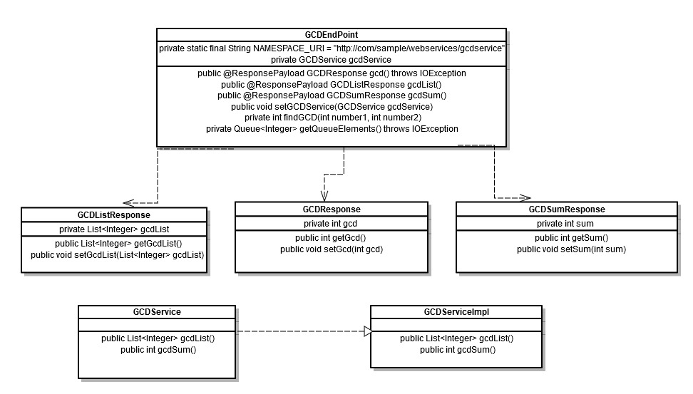

Implementation:
Spring Implementation:
Used Spring framework Web service implementations. Spring Web Services is following the strategy of contract-first web services.

Implementation Steps Followed:
- In order to calculate gcd, return the list of all gcd from the database and sum of all the gcds. Created a XSD GCDServiceOperations.XSD which include GCDResponse, GCDListResponse and GCDSumResponse. The Location of the xsds is src\main\webapp\schemas.
<xsd:element name="GCDResponse">
<xsd:complexType>
<xsd:sequence>
<xsd:element name="gcd" type="xsd:int" minOccurs="1" maxOccurs="1"/ </xsd:sequence>
</xsd:complexType>
</xsd:element>
<xsd:element name="GCDListResponse">
<xsd:complexType>
<xsd:sequence>
<xsd:element name="gcdList" type="xsd:integer" minOccurs="1"maxOccurs="unbounded"/>
</xsd:sequence>
</xsd:complexType>
</xsd:element>
<xsd:element name="GCDSumResponse">
<xsd:complexType>
<xsd:sequence>
<xsd:element name="gcdSum" type="xsd:int" minOccurs="1" maxOccurs="1"/>
</xsd:sequence>
</xsd:complexType>
</xsd:element>

- Generated the POJO through XSDs (GCDResponse, GCDListResponse and GCDSumResponse).
- Generated WSDL named GCD.wsdl
- Created Endpoint class named as ‘GCDEndPoint’ that will implement three method gcd(), gcdList() and gcdSum().
- Gcd() will return GCDResponse that represents the calculated gcd of the two integers at the head of the queue and will subsequently be discarded them from the queue and the head replaced by the next two in line. The user can add as many elements into the queue from the command prompt and the method will pick the two elements from the head of the queue to calculate the gcd and discard them. The Queue will have the remaining elements then.
- Also, gcdList() will returns GCDListResponse that represents a list of all the computed gcd from a database. gcdSum() will returns GCDSumResponse that will have the sum of all computed gcd from a database.
- In order to make database call, GCDService interface and GCDServiceImpl class is created.

Location of the Applications on GitHub:
REST - https://github.com/kanak-sharma/RestWebService
SOAP- https://github.com/kanak-sharma/SOAPWebService

